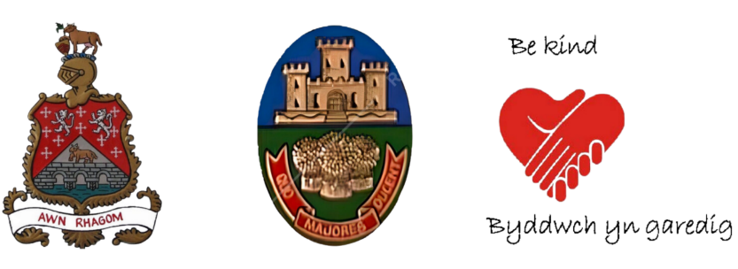
Cowbridge (Ancient Borough) with Llanblethian Town Council

Appointment of a Chief Officer
(Full Time)
Salary Scale SCP: 32 – 35 (£41,511 - £44,711 per annum)

Plus Generous Local Government Pension Scheme

Are you a strong leader; do you think strategically; have you built successful organisations; can you communicate well, delegate effectively, and make the difficult decisions? Then why not join us? Cowbridge with Llanblethian Town Council is seeking a dynamic and proactive Chief Officer who can lead and support Councillors and staff.

As Chief Officer you will be expected to maintain statutory duties, a high level of corporate governance and be accountable to the Council for the effective management of all its resources.

The successful candidate will lead staff and work closely with Councillors and partners, maintaining and building new relationships in the local community to deliver local services, ensuring the town of Cowbridge has a strong voice across the area.

Would you like to know more? To obtain an information pack with full details of the role and application form, please email:
recruitment@chrgs.co.uk

Applications must be received by 9am on Friday, 7 March 2025

Please note CVs will not be considered

Interviews will be held on 13 March 2025 and, for those called for a
second interview, these will be held on 14 March 2025

If, after reading the information pack, you would like to discuss this position, please contact the Council’s HR advisor, Helen Plant, at Council HR & Governance Support on 07939 400548

