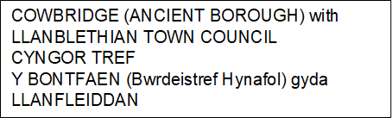

Minutes of the Extraordinary Meeting 5th February 2025

Present at the meeting: Mayor Cllr Weddell, Deputy Mayor Geraint Baty, Cllrs Champion, Williams, Wilson, Sami and Harbour.

012025 APOLOGIES FOR ABSENCE
Apologies were noted from Cllrs Gwen Baty, Hannigan Davies, Andrew, Evans, John, Bond

022025 DECLARATIONS OF INTEREST
To receive any declarations of interest, including the reason for the interest (members are reminded of the provisions of paragraph 11 of the Members Code of Conduct, specifically paragraph 11.1).

There were no declarations of interest.

032025 TO DISCUSS AND APPROVE MONEY FOR THE URGENT WORKS NEEDED AT WAITROSE
Approval was given to give the contractor ASR to commence works next week with the council money and recoup from S106 monies when it comes in. the decision was made as to not lose the costing given on the quote which is over a year old and not to have to wait a further 12 weeks that the contractor will be on another job.

042025 DATE OF NEXT MEETING
To be confirmed

